Acceptance tests
Acme-Poll 1.0
Development team
Identifier | FINALFANTASY
Members | SANCHEZ REYES, ADRIAN  BOZADA MARQUEZ, JESUS ENRIQUE  GIRALDO RUIZ, JOSE  LOPEZ MUÑOZ, JUAN CARLOS  DANS CABALLERO, MARIA REMEDIOS  CAMPOS ROMERO, MIGUEL
Testing team
Identifier | ReiCarMacLuqQuiMin
Members | CARRASCOSA OLIVA, SERGIO  REINA LOPEZ, PABLO  LUQUE MENDOZA, JOSÉ MANUEL  VALERA QUIANO, SILVIA  MINGUEZ LEÓN, ANTONIO JESÚS  MACÍAS LÓPEZ, PABLO
Indexing data
Test designers | GIRALDO RUIZ, JOSÉ  DANS CABALLERO, MARÍA REMEDIOS
Testers | CARRASCOSA OLIVA, SERGIO  REINA LOPEZ, PABLO
Notes

Table of contents
LEVEL C 3
Use case 001 Browse the catalogue of polls available 3
Use case 002 Search for a poll using a single key word that must appear somewhere in its title, de-scription, or ticker 4
Use case 003 Answer a poll and produce an instance as long as it’s active and he or she does not seem to have answered it before. Tracking must be implemented using appropriate cookies 5
Use case 004 See the results of a poll as soon as it starts. The results must list each individual question and the count of users that have selected each answer 6
Use case 005 Edit his or her personal data 7
Use case 006 Manage his or her polls, which includes listing, editing, or deleting them. Editing or deleting a poll is allowed as long as its start date has not passed; once the start date has passed, polls must be frozen 8
Use case 007 Ban or unban a poller who he or she thinks is publishing inappropriate polls 10
Use case 008 Display a dashboard with the following information 11
LEVEL B 12
Use case 009 Browse its hints 12
Use case 010 Write a new hint 13
Use case 011 State how useful he or she thinks a hint is using 0-10 stars 14
Use case 012 Delete hints that he or she thinks are inappropriate 15
LEVEL A 16
Use case 013 Manage his chirps, which includes listing and writing them. Note that once a chirp is published, it cannot be edited or deleted 16
Use case 014 Display other actors’ chirps 18
Additional tests 19

LEVEL C

Use case 001 Browse the catalogue of polls available

Description
A non authenticated actor must be able to browse the catalogue of polls available
Access
Everyone can access this use case
Tests
Test 1
Description | Browse the catalogue of polls available
Expected | Once in the master page, the 'Catalogue of Polls'. tab will lead to the list view. It must work in both languages.
Outcome | Se muestra correctamente:  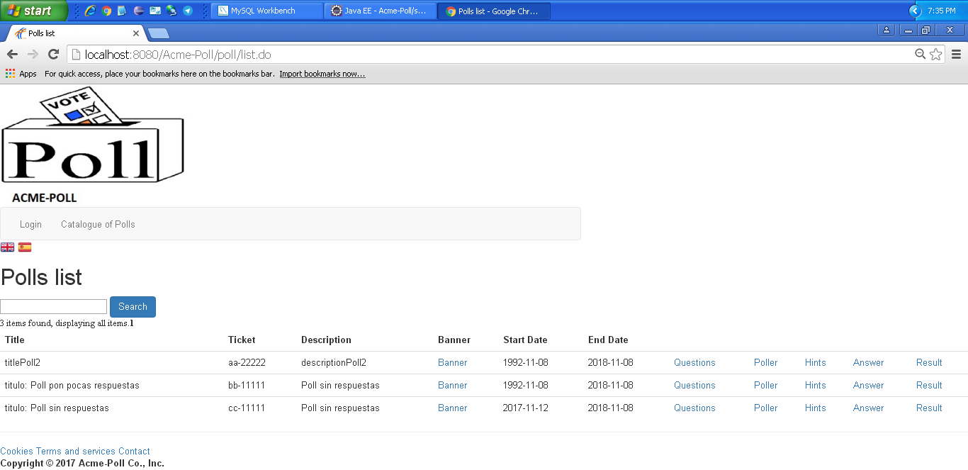
Notes

Use case 002 Search for a poll using a single key word that must appear somewhere in its title, de-scription, or ticker

Description
A non authenticated actor must be able to search for a poll using a single key word that must appear somewhere in its title, de-scription, or ticker
Access
Everyone can access this use case
Tests
Test 1
Description | Search for a poll using a single key word that must appear somewhere in its title, de-scription, or ticker
Expected | Once in the master page, the 'Catalogue of Polls'. tab will lead to the list view. It must work in both languages.
Outcome | Funciona correctamente:  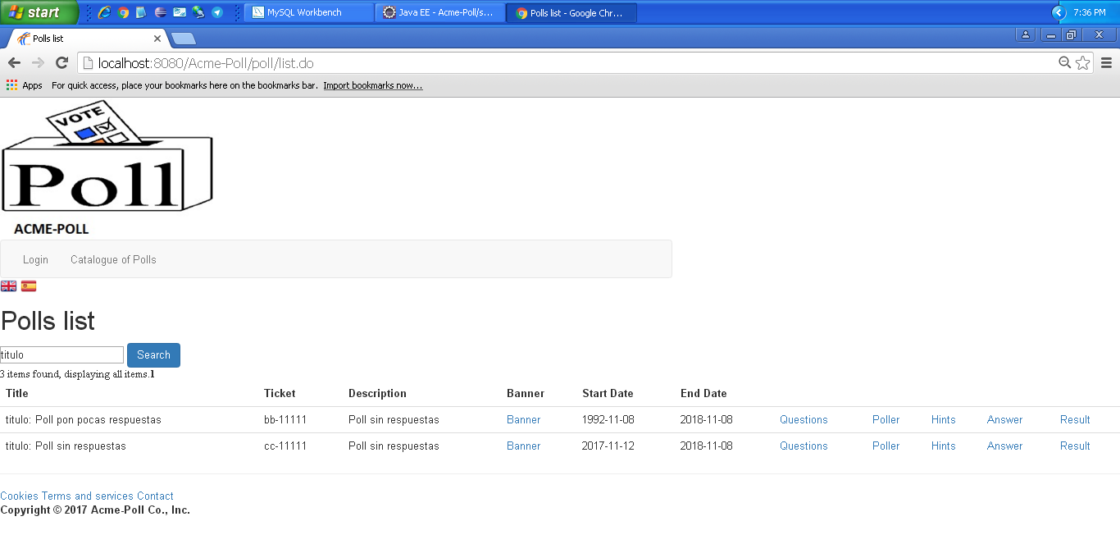
Notes

Use case 003 Answer a poll and produce an instance as long as it’s active and he or she does not seem to have answered it before. Tracking must be implemented using appropriate cookies

Description
A non authenticated actor must be able to answer a poll and produce an instance as long as it’s active and he or she does not seem to have answered it before. Tracking must be implemented using appropriate cookies
Access
Everyone can access this use case
Tests
Test 1
Description | Answer a poll and produce an instance as long as it’s active and he or she does not seem to have answered it before. Tracking must be implemented using appropriate cookies
Expected | Once in the master page, the 'Catalogue of Polls - Answer'. tab will lead to the answer view. It must work in both languages.
Outcome | Encuesta sin rellenar:  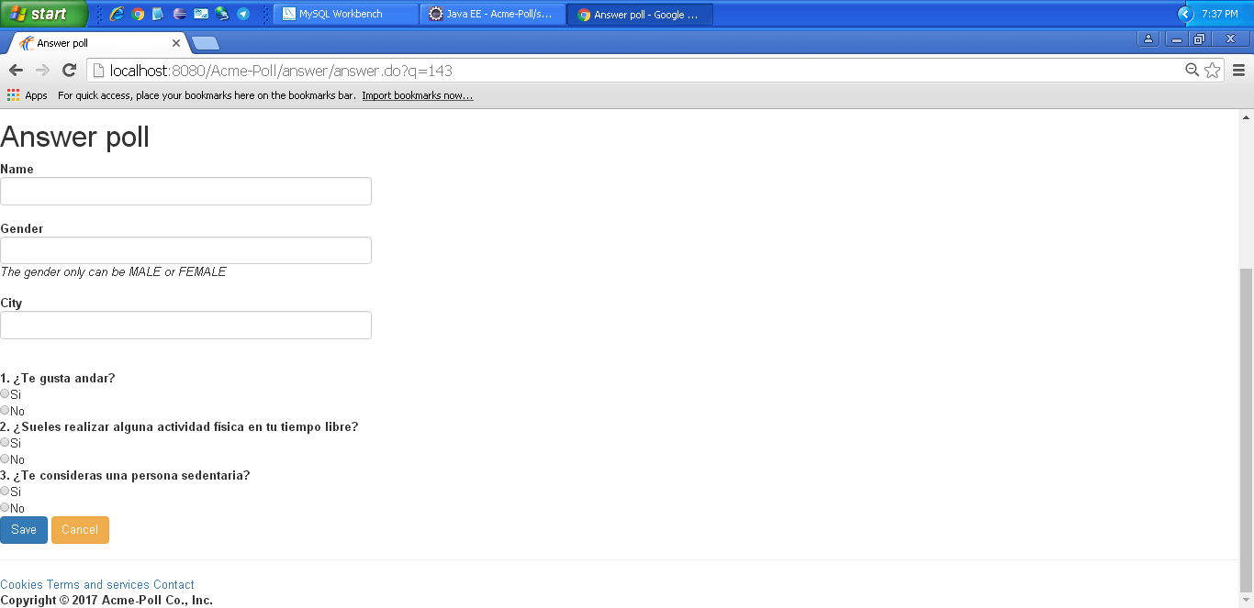  Nos permite rellenar y enviar la encuesta correctamente.
Notes
Test 2
Description | Answer a poll and produce an instance as long as it’s active and he or she does not seem to have answered it before. Tracking must be implemented using appropriate cookies
Expected | Dejamos la encuesta sin rellenar. No nos deja rellenarla.
Outcome | Error. Nos deja rellenarla.
Notes

Test 3
Description | Answer a poll and produce an instance as long as it’s active and he or she does not seem to have answered it before. Tracking must be implemented using appropriate cookies
Expected | Introducimos un género diferente al indicado.
Outcome | Error. Nos permite rellenar la encuesta sin modificar el gender.
Notes

Use case 004 See the results of a poll as soon as it starts. The results must list each individual question and the count of users that have selected each answer

Description
A non authenticated actor must be able to see the results of a poll as soon as it starts. The results must list each individual question and the count of users that have selected each answer
Access
Everyone can access this use case
Tests
Test 1
Description | See the results of a poll as soon as it starts. The results must list each individual question and the count of users that have selected each answer
Expected | Once in the master page, the 'Catalogue of Polls - results'. tab will lead to the list view. It must work in both languages.
Outcome | Correcto. Nos deja ver los resultados de una encuesta:  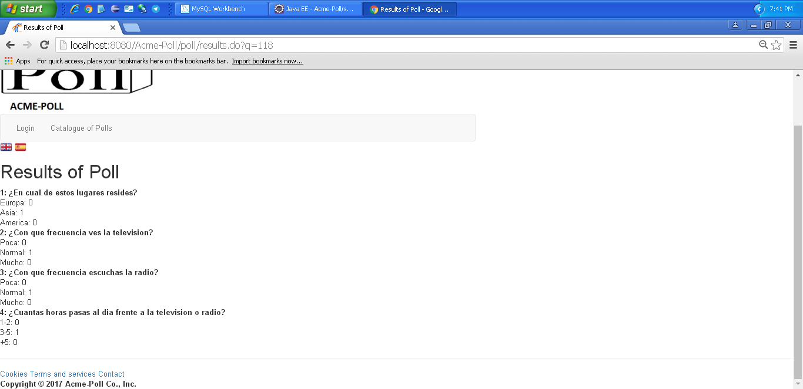
Notes

Use case 005 Edit his or her personal data

Description
An actor must be able to access edit his or her personal data
Access
Any authenticated actor can access this use case. Please, use the following credentials:
User: poller1
Password: poller1
User: admin
Password: admin
Tests
Test 1
Description | Edit his or her personal data
Expected | Once logged in, the 'Edit' tab will lead to the edit view. It must work in both languages.
Outcome | Ok. Formulario de editar:  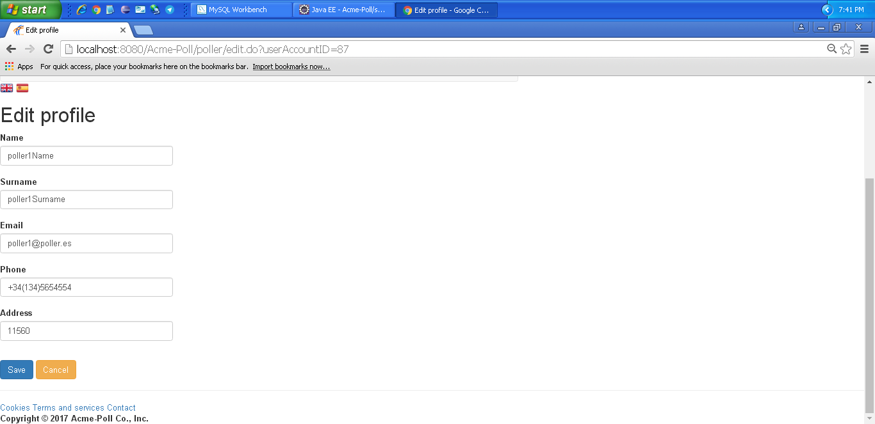
Notes

Test 2
Description | Edit his or her personal data
Expected | Once logged in, the 'Edit' tab will lead to the edit view. It must work in both languages.  Intentamos dejar todos los campos en blanco. Nos muestra un error indicando los campos que se deben rellenar.
Outcome | Ok. Nos indica los errores correctamente:  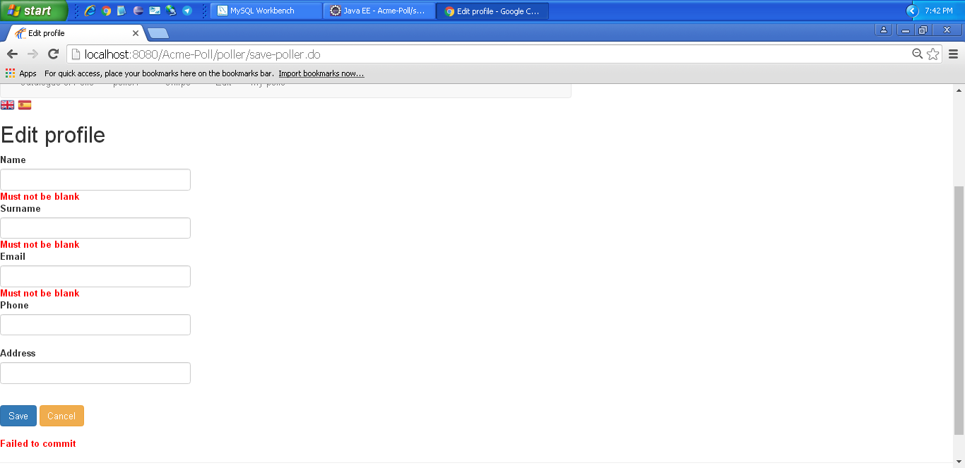
Notes

Test 3
Description | Edit his or her personal data
Expected | Once logged in, the 'Edit' tab will lead to the edit view. It must work in both languages. Intentamos introducir un teléfono no válido como “abcd”.
Outcome | Error. Nos deja introducir un télefono incorrecto.
Notes

Test 4
Description | Edit his or her personal data
Expected | Once logged in, the 'Edit' tab will lead to the edit view. It must work in both languages. Intentamos introducir un email no válido como “emailnoválido”.
Outcome | Error. Nos deja introducir un email incorrecto.
Notes

Use case 006 Manage his or her polls, which includes listing, editing, or deleting them. Editing or deleting a poll is allowed as long as its start date has not passed; once the start date has passed, polls must be frozen

Description
A poller must be able to access manage his or her polls, which includes listing, editing, or deleting them. Editing or deleting a poll is allowed as long as its start date has not passed; once the start date has passed, polls must be frozen
Access
Any authenticated actor can access this use case. Please, use the following credentials:
User: poller1
Password: poller1
Tests
Test 1
Description | List Polls
Expected | Once logged in, 'My polls' tab will lead to the list view. It must work in both languages.
Outcome | Ok. Lista de my polls:  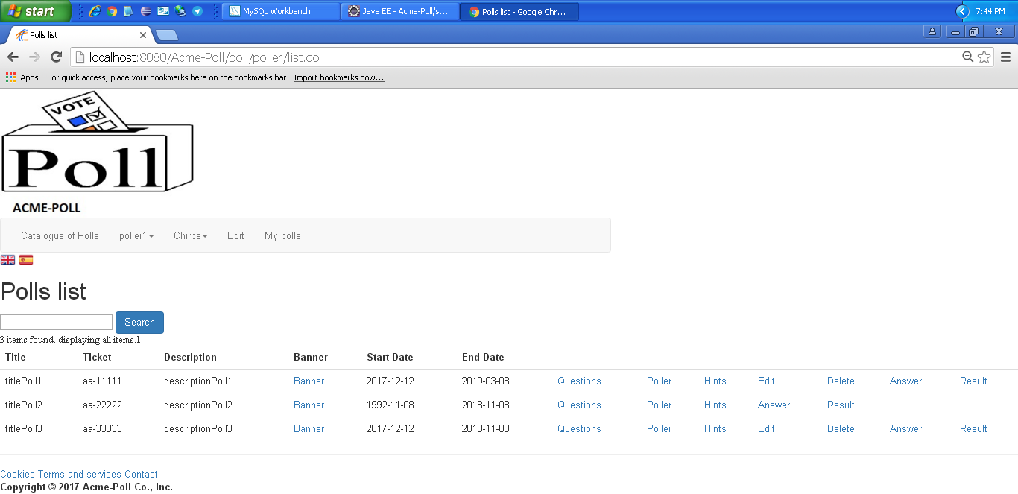
Notes

Test 2
Description | Edit Poll
Expected | Once logged in, 'My polls - edit' tab will lead to the edit view. It must work in both languages.
Outcome | Ok. Formulario de editar poll:  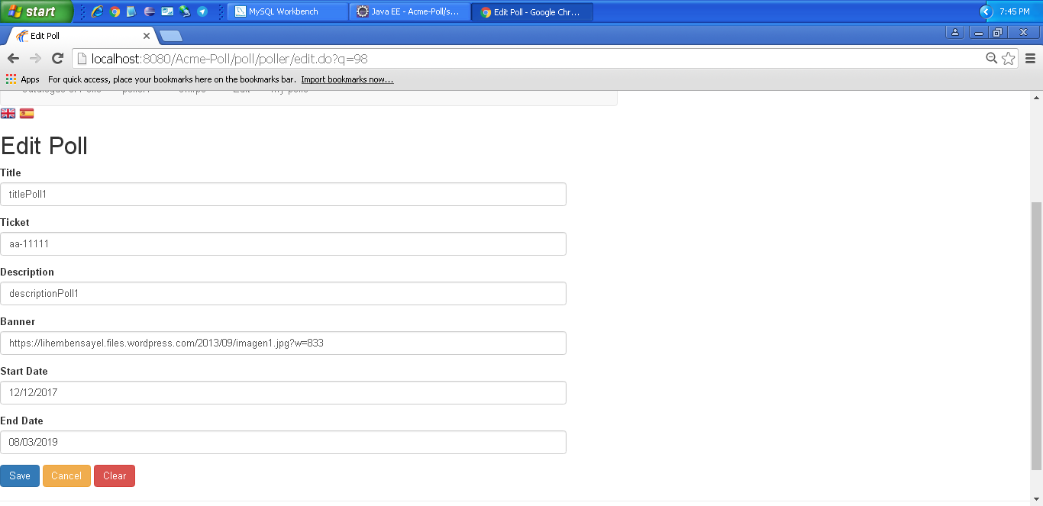  Poll editado:  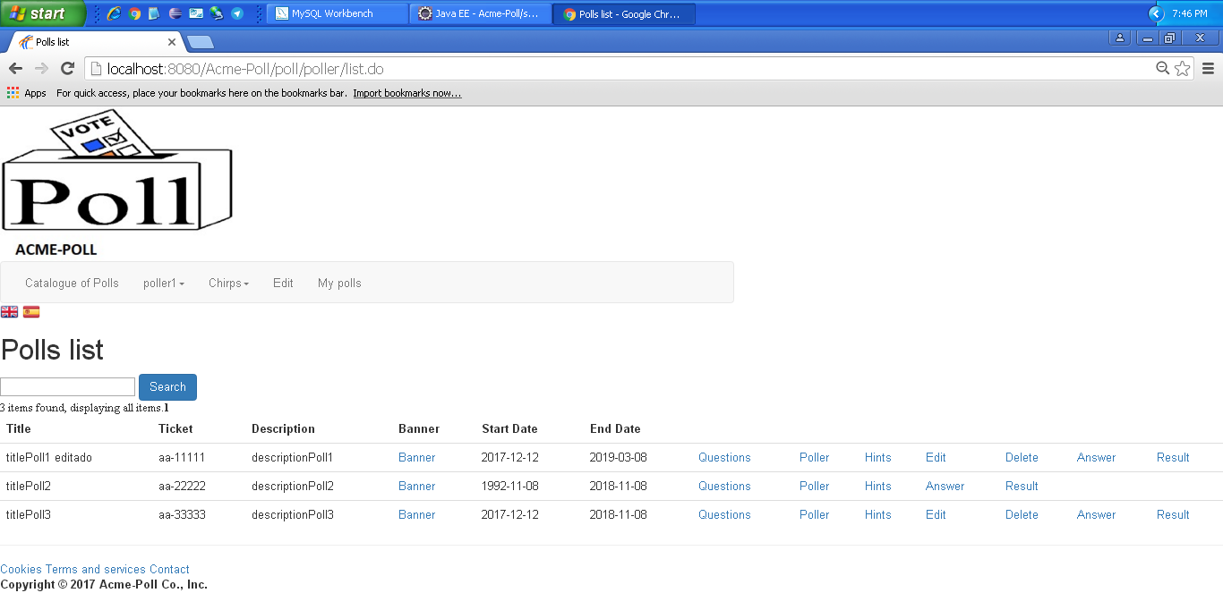
Notes

Test 3
Description | Edit Poll
Expected | Once logged in, 'My polls - edit' tab will lead to the edit view. It must work in both languages.  Intentamos dejar todos los campos en blanco. Nos muestra los mensajes de error adecuadamente.
Outcome | Error. Salta una pantalla con errores.  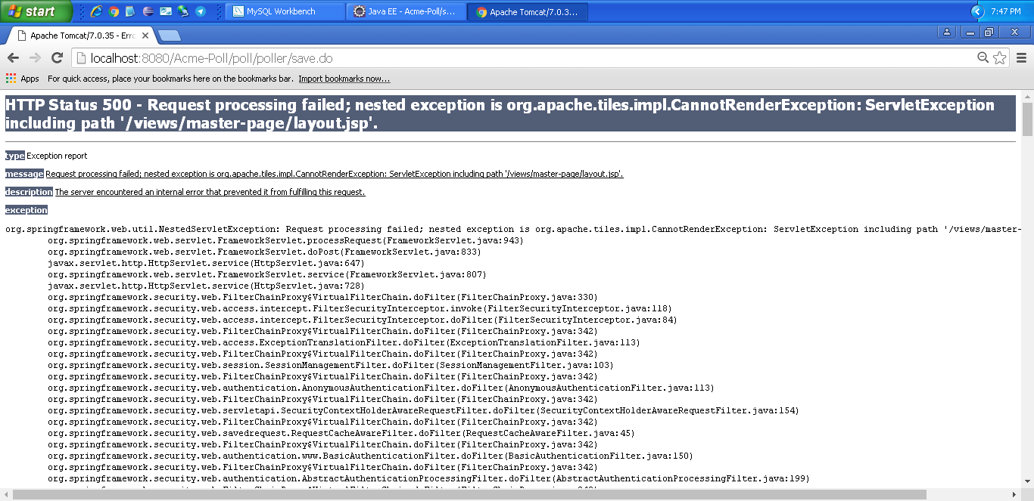
Notes

Test 4
Description | Delete Poll
Expected | Once logged in, 'My polls - delete'. It must work in both languages.
Outcome | Ok.  Antes:  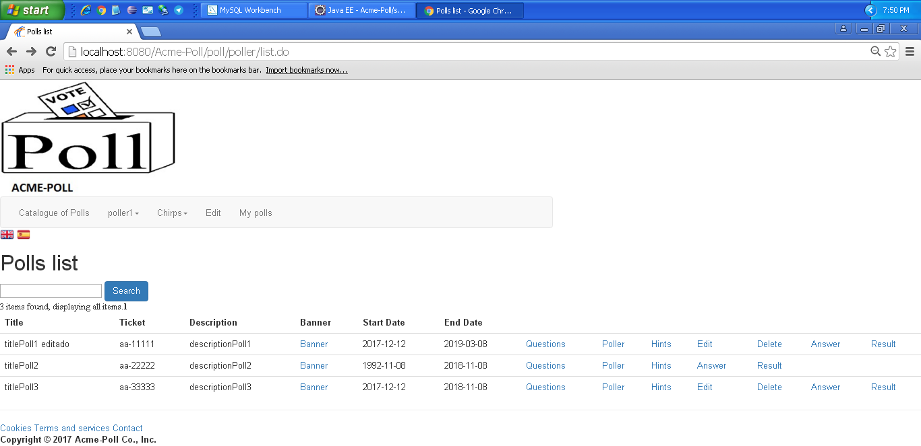  Después:  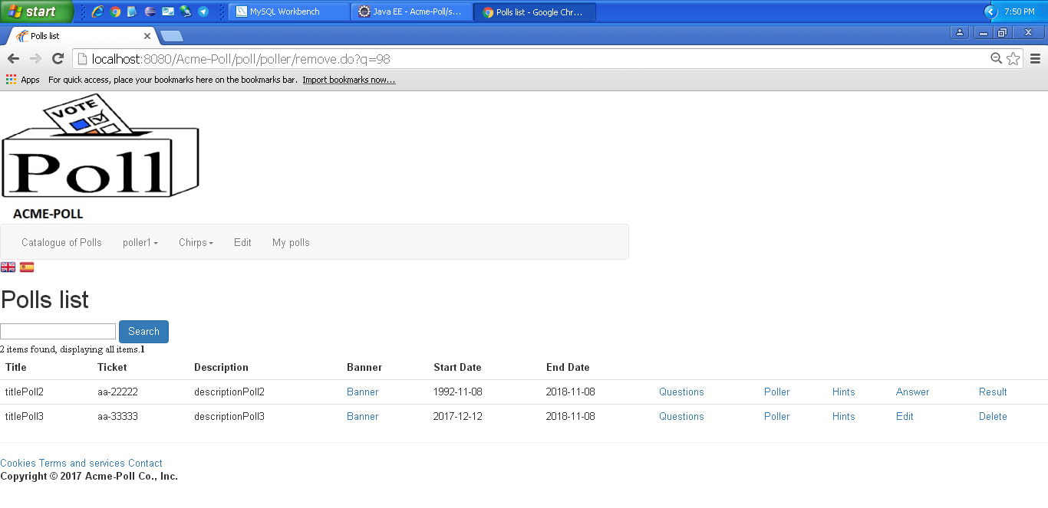
Notes

Use case 007 Ban or unban a poller who he or she thinks is publishing inappropriate polls

Description
An admin must be able to access ban or unban a poller who he or she thinks is publishing inappropriate polls
Access
Any authenticated actor can access this use case. Please, use the following credentials:
User: admin
Password: admin

Tests
Test 1
Description | Ban or unban a poller who he or she thinks is publishing inappropriate polls
Expected | Once logged in, 'Poller list - ban'. It must work in both languages.
Outcome | Ok. Lista de pollers:  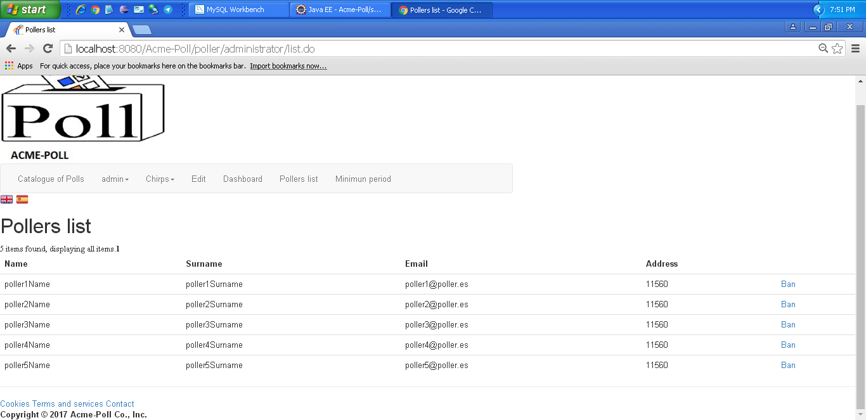  Baneamos a un poller:  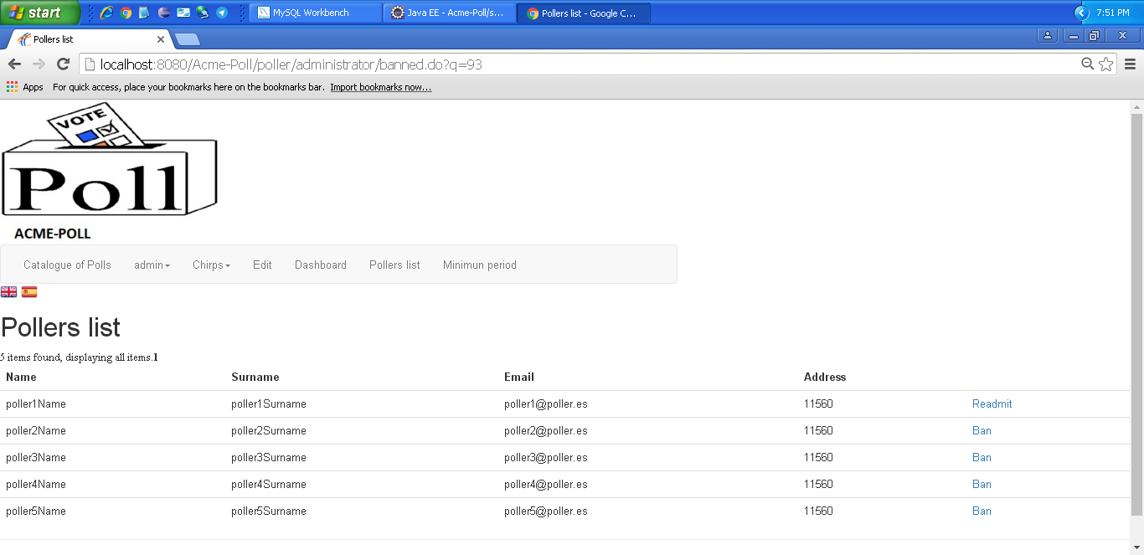  Intentamos iniciar sesión:  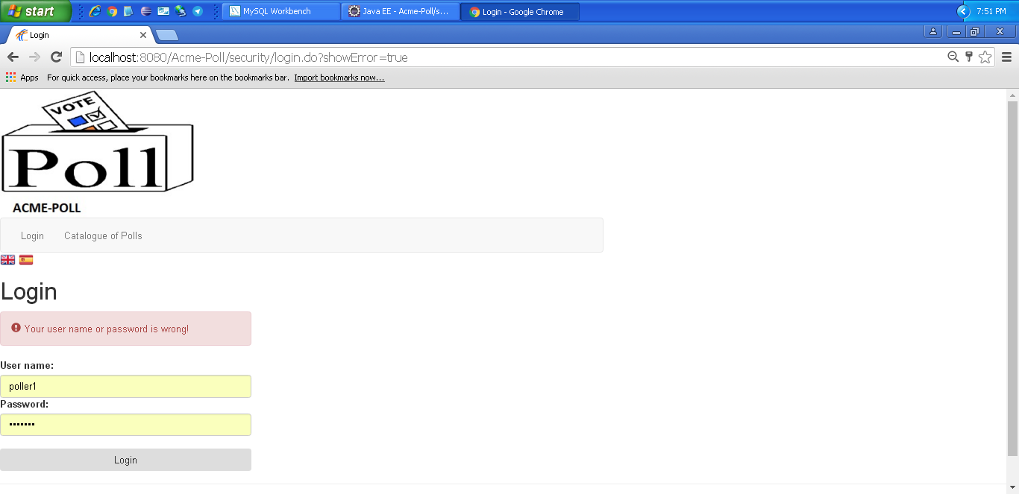
Notes

Use case 008 Display a dashboard with the following information

Description
An admin must be able to access display a dashboard with the following information
Access
Any authenticated actor can access this use case. Please, use the following credentials:
User: admin
Password: admin
Tests
Test 1
Description | Display a dashboard with the following information
Expected | Once logged in, 'Dashboard' tab will lead to the list view. It must work in both languages.
Outcome | Ok. Se muestra el dashboard correctamente:  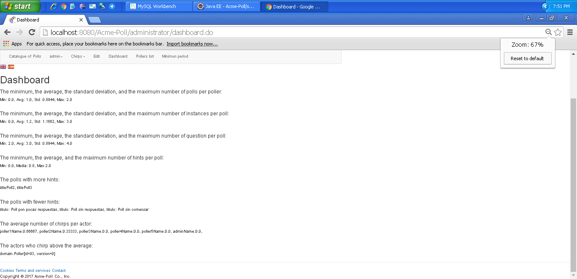
Notes

LEVEL B

Use case 009 Browse its hints

Description
An actor must be able to access browse its hints
Access
Everyone can access this use case
Tests
Test 1
Description | Browse its hints
Expected | Once in the master page, the 'Catalogue of Polls - hints'. tab will lead to the list view. It must work in both languages.
Outcome | Ok. Lista de hints:  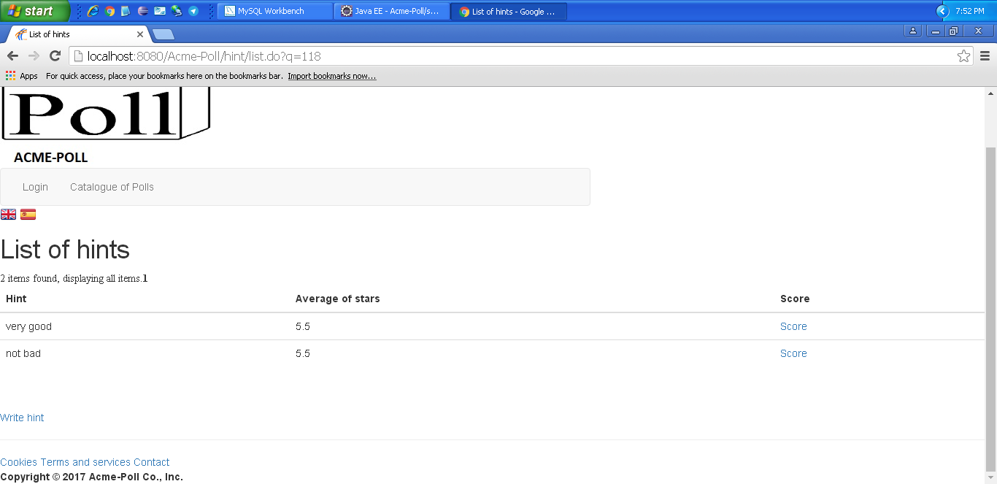
Notes

Use case 010 Write a new hint

Description
An actor must be able to access write a new hint
Access
Everyone can access this use case
Tests
Test 1
Description | Write a new hint
Expected | Once in the master page, the 'Catalogue of Polls - hints - write hint'. tab will lead to the write view. It must work in both languages.
Outcome | Ok.  Formulario de creación de un hint:  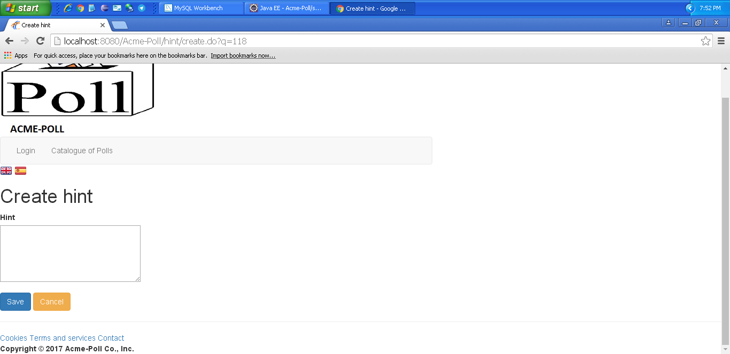  Hint creado:  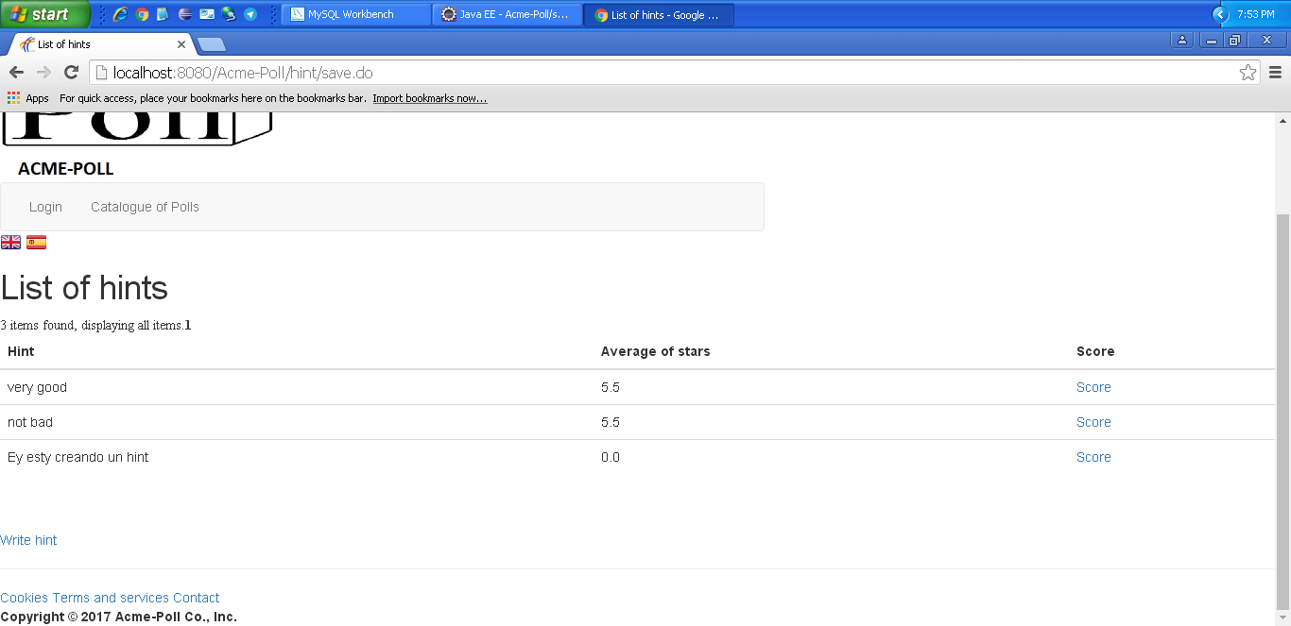
Notes

Test 2
Description | Write a new hint
Expected | Once in the master page, the 'Catalogue of Polls - hints - write hint'. tab will lead to the write view. It must work in both languages.  Intentamos dejar todos los campos en blanco. Nos muestra los errores correctamente.
Outcome | Ok.
Notes

Use case 011 State how useful he or she thinks a hint is using 0-10 stars

Description
An actor must be able to state how useful he or she thinks a hint is using 0-10 stars
Access
Everyone can access this use case
Tests
Test 1
Description | State how useful he or she thinks a hint is using 0-10 stars
Expected | Once in the master page, the 'Catalogue of Polls - hints - Score'. tab will lead to the score view. It must work in both languages.
Outcome | Ok. Formulario para puntuar un hint:  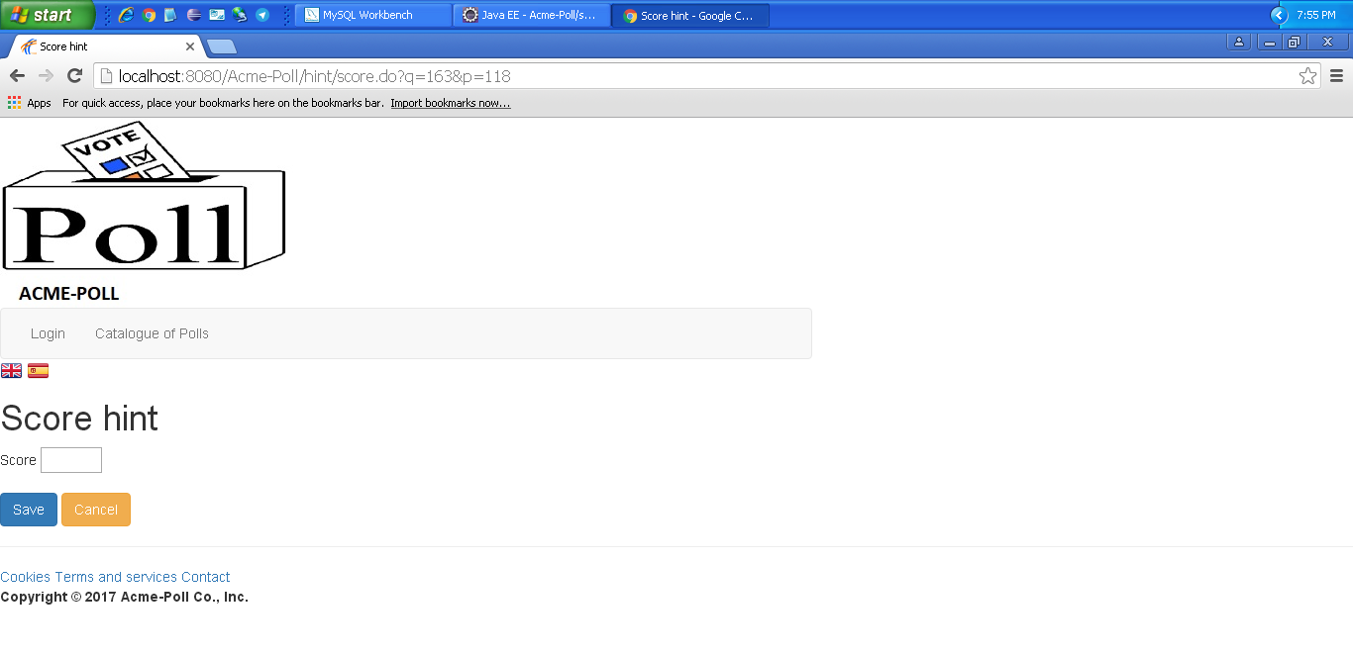  Funciona correctamente actualizándose la media de puntos.
Notes

Use case 012 Delete hints that he or she thinks are inappropriate

Description
An admin must be able to delete hints that he or she thinks are inappropriate
Access
Any authenticated actor can access this use case. Please, use the following credentials:
User: admin
Password: admin
Tests
Test 1
Description | Delete hints that he or she thinks are inappropriate
Expected | Once in the master page, the 'Catalogue of Polls - hints - Delete'. It must work in both languages.
Outcome | Aparece el botón de eliminar:  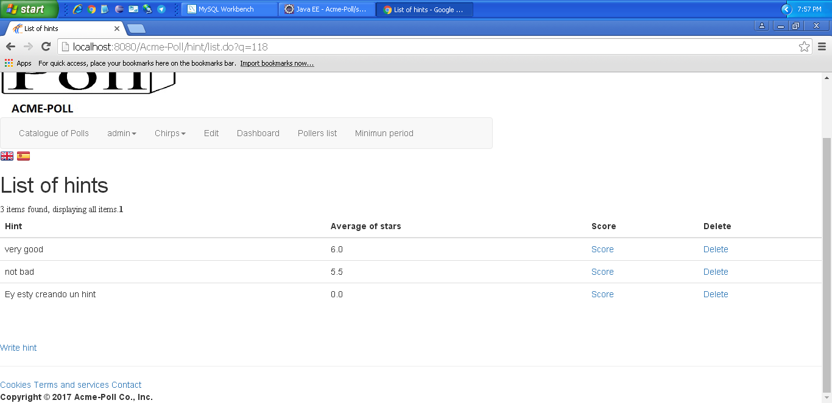  Se elimina correctamente:  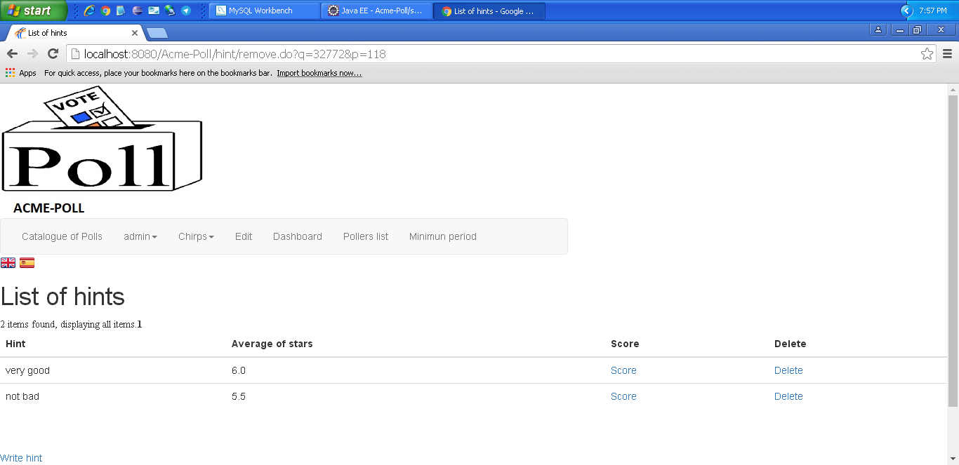
Notes

LEVEL A

Use case 013 Manage his chirps, which includes listing and writing them. Note that once a chirp is published, it cannot be edited or deleted

Description
An actor must be able to access manage his chirps, which includes listing and writing them. Note that once a chirp is published, it cannot be edited or deleted
Access
Any authenticated actor can access this use case. Please, use the following credentials:
User: poller1
Password: poller1
User: admin
Password: admin

Tests
Test 1
Description | List chirps
Expected | Once logged in, 'Chirps - Chirps general - Chirps'. tab will lead to the list view. It must work in both languages.
Outcome | Ok. Se muestra la lista correctamente:  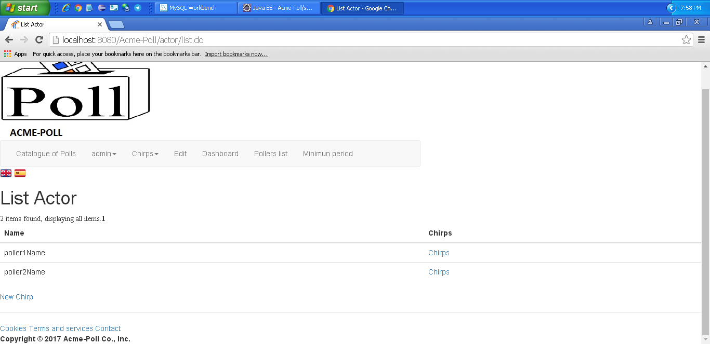
Notes

Test 2
Description | Write chirps
Expected | Once logged in, 'Chirps - Chirps general - New Chirp'. tab will lead to the write view. It must work in both languages.
Outcome | Input para escribir un chirp:  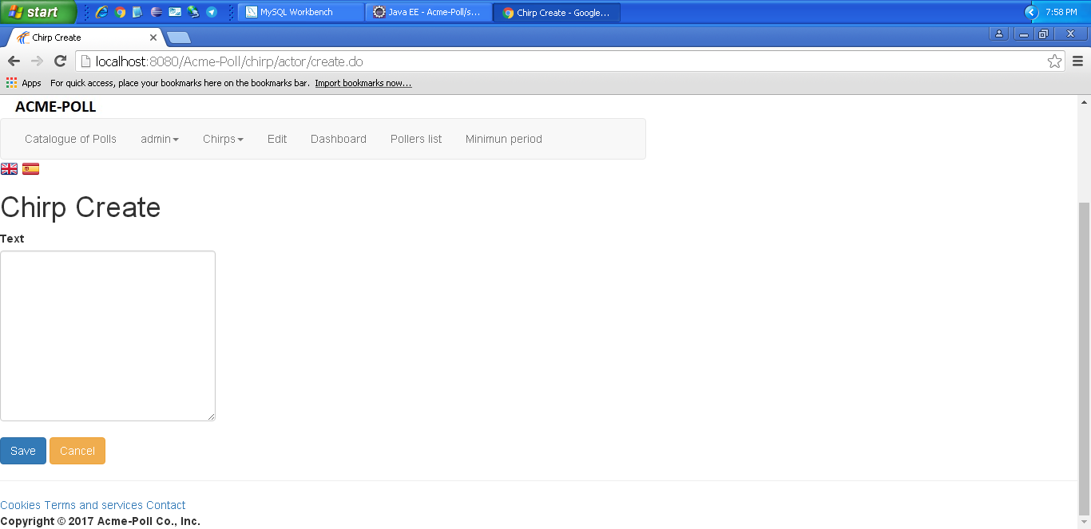  Chirp creado:  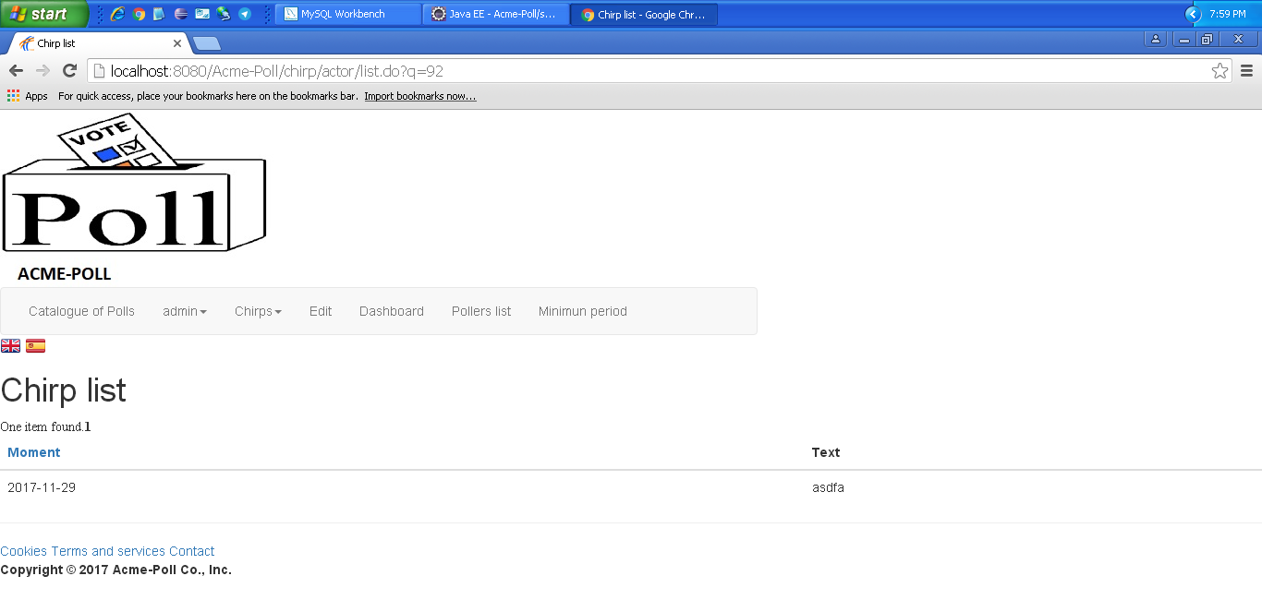
Notes

Test 3
Description | Write chirps
Expected | Once logged in, 'Chirps - Chirps general - New Chirp'. tab will lead to the write view. It must work in both languages.  Dejamos todos los campos en blanco. Nos muestra los mensajes de error correctamente.
Outcome | Ok.  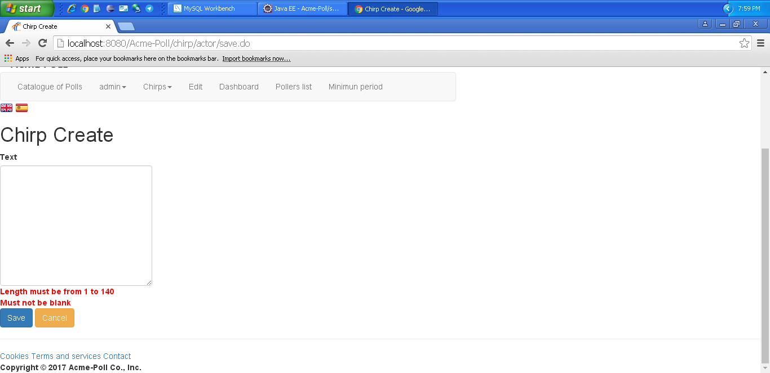
Notes

Use case 014 Display other actors’ chirps

Description
An actor must be able to access display other actors’ chirps
Access
Any authenticated actor can access this use case. Please, use the following credentials:
User: poller1
Password: poller1
User: admin
Password: admin
Tests
Test 1
Description | Display other actors’ chirps
Expected | Once logged in, 'Chirps - Chirps general'. tab will lead to the list view. It must work in both languages.
Outcome | Ok. Se muestran correctamente los chirps de otros actores:  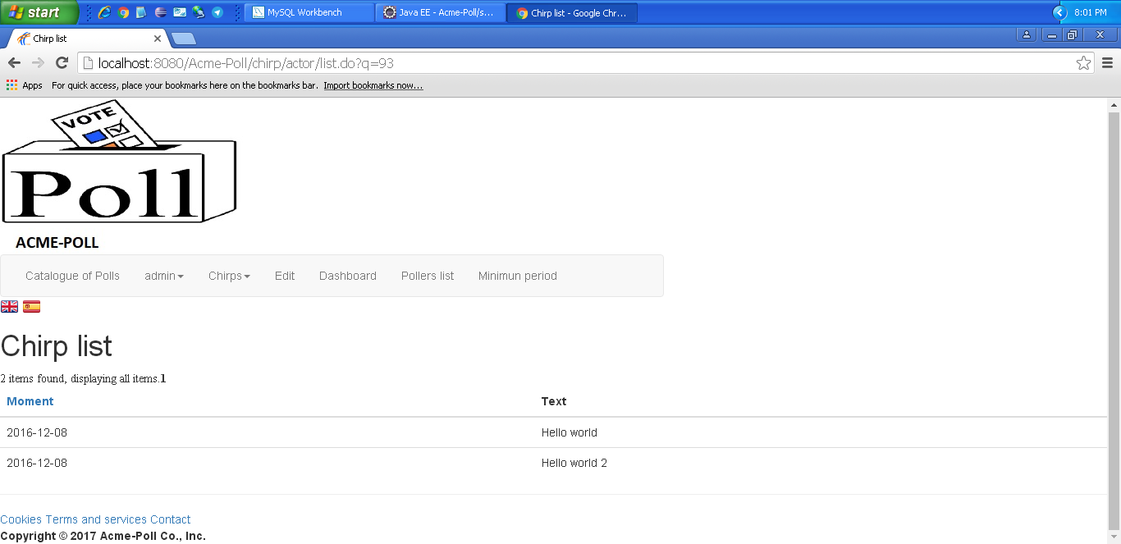
Notes

